Student Name: _________________________________________________
Excursion: Year 7 Day Excursion

Preferred Payment Options:
QUICKWEB – Online via the MCSS website
http://www.mcss.act.edu.au/payment2/Make_a_payment
QUICKWEB Payment option example:
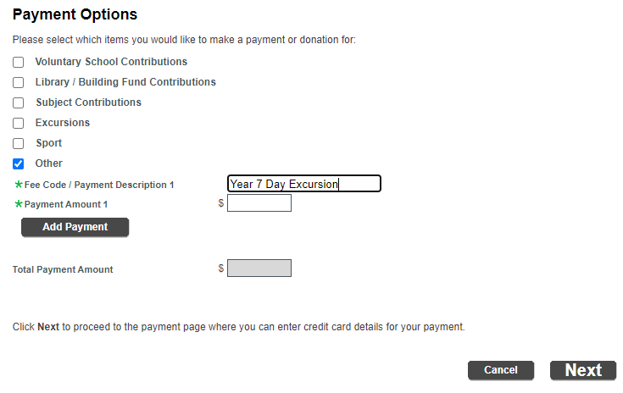
By EFTPOS at the School reception

