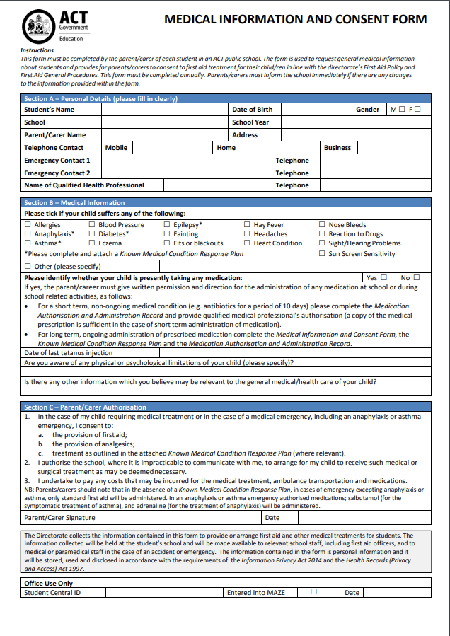
Dear Parent/guardian

MEDICAL INFORMATION/CONSENT AND KNOWN MEDICAL CONDITION RESPONSE PLAN
I am attaching a Medical Information and Consent Form and a Known Medical Condition Response Plan for you to complete and return as soon as possible. This information will assist school staff to provide appropriate first aid support for your child.
The Medical Information and Consent Form provides general medical information and consent for first aid and the administration of authorised medications; salbutamol (ventolin) and adrenaline in the event of a life threatening asthma or anaphylaxis emergency.
The Known Medical Condition Response Plan is required only for students with a known medical condition. It provides instruction for the management of an identified medical condition and should be completed in consultation with the treating health professional. Without this form, in an emergency situation first aid can only be given in accordance with a publically available generalised action plan related to the condition.
If medication is required to be administered at school a Medication Authorisation and Administration Record must also be completed and returned to the school. An individual Medication Authorisation and Administration Record must be completed for each medication.
It is important that information on these forms is accurate and detailed in order to help us provide appropriate care. The Medical Information and Consent Form and Known Medical Condition Response Plan will be sent to you annually for your review. However, if there are changes to your child’s health or medical circumstances, during the year, please inform the school immediately. You may also choose to keep certain medical information private. When making this choice, please consider whether this might affect the provision of appropriate firs aid care for your child.
If an incident occurs at school or during a school-related activity in the ACT, students will be transported free of charge to the emergency section of an ACT public hospital. Parents/carers are reminded to check their health cover for ambulance transportation outside the ACT, as charges may apply.
Please complete and promptly return the attached forms to assist staff to provide appropriate first aid support for your child.
Yours sincerely
Shannon Carnovale
Principal
Melba Copland Secondary School
All students must return:
- Medical Information and Consent Form
Students with a known medical condition which does not require medication must return:
- Medical Information and Consent Form
- Known Medical Condition Response Plan
Students with a known medical condition not listed below who require medication must return:
- Medical Information and Consent Form
- Known Medical Condition Response Plan
- Medication Authorisation and Administration Record
Students with Asthma must return:
- Medical Information and Consent Form
- Known Medical Condition Response Plan
- Asthma Management Plan downloaded from National Asthma Organisaton Website
- Medication Authorisation and Administration Record
Students with Anaphylaxis must return:
- Medical Information and Consent Form
- Known Medical Condition Response Plan
- Anaphylaxis Management Plan downloaded from Australian Society of Clinical Immunology and Allergy Website
- Medication Authorisation and Administration Record
Students with Diabetes must return:
- Medical Information and Consent Form
- Known Medical Condition Response Plan
- Diabetes Management Plan downloaded from Diabetes Victoria Website (click on “How we help” and “Schools and early childhood settings”)
- Medication Authorisation and Administration Record
Students with Epilepsy must return:
- Medical Information and Consent Form
- Known Medical Condition Response Plan
- Epilepsy Management Plan downloaded from Epilepsy Action Australia Website (Register and call 1300374537 for free access)
- Medication Authorisation and Administration Record

