MAGELLAN PROGRAM
WHERE GIFTED AND TALENTED STUDENTS SHINE WHERE STUDENTS LOVE TO LEARN

www.mcss.act.edu.au

What is the Magellan Program?

The Magellan Program offers students the chance to work in classes which are structured for highly motivated and talented students with above average ability, who are able and willing to work in an academically challenging environment.
Magellan classes gather together students who have demonstrated both ability and a willingness to participate actively in their schoolwork. Students will demonstrate their ability to work both independently and in productive partnerships with minimal teacher direction.

Teachers of Magellan classes can challenge students with work in greater depth, and with enrichment or extension activities.

How is the Magellan Program special?

Students in the Magellan Program are placed in ability-streamed classes in English, Mathematics, Sciences and SOSE/HASS. Magellan students are strongly encouraged to participate in academic competitions and co-curricular opportunities.

The Magellan Program is excellent preparation for developing higher order skills in readiness for students’ college years at Melba Copland Secondary School.
Demonstrated high levels of achievement assist in entering higher level courses at secondary college.

Which students enter the Magellan Program?

Students who are accepted into the Magellan Program will have demonstrated a high standard of academic achievement in primary school and a willingness to work consistently at a high level. MCSS is looking for students who are also engaged in activities beyond the classroom, as part of the wider community.

It is assumed that parents or guardians will actively support students in the Magellan Program.

How does a student gain entry to the Magellan Program?

Consistent with the ACTETD Gifted and Talented Student Policy, a transparent, ethical process using multiple criteria and tools appropriate to the MCSS community and

population will be used to identify students for the Fast-Paced Program. Students currently in the Primary Magellan Program are granted automatic entry. The process for a student to be considered for the Magellan program with include the following:
- Completion and submission of the attached application form by Friday 3rd June 2022.
- Parents and students may be invited for an interview.
- Samples of work completed at primary school, results of literacy and numeracy assessments and previous school reports should be brought to the interview.
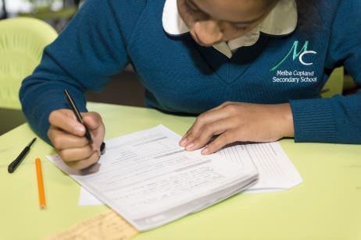
- Information will be sought from primary school teachers about the suitability of a student for the MCSS Magellan Program
- Students will be required to undertake testing
(PAT Reading, PAT Maths) which will
occur in July 2022 (dates to be confirmed).
Application forms are enclosed with this brochure.

Specific Skills

Successful Magellan students are characterised by a high level of academic skills, evidence of which could include:

- Above average grades in key subjects
- An inquiring approach and independent learning skills
- Being a reader by choice
- Expressing ideas and information confidently and creatively in a variety of communication modes
- Interest in gaining in-depth knowledge
- NAPLAN and Academic Competition results
- Showing a thoughtful consideration of their own learning

Formation of Classes

Magellan classes are formed from students selected by this process. Eligible students who cannot be placed in the classes because of lack of room will be placed on a short list and may be offered places early in Year 7 if places become available. Priority is given to students in the MCSS Priority Placement Area (including Northern NSW Region students) and those students who complete the application process in the dates provided.

Later Entry

The progress of participants in Magellan classes is reviewed regularly. Students in mainstream classes who demonstrate through their work and overall readiness that they would benefit from placement in a Magellan class may be offered a place during Year 7 or Year 8.
Class placements are reviewed every semester. If students are not maintaining a B grade average in the Magellan classes, their may be movement in their class placement.

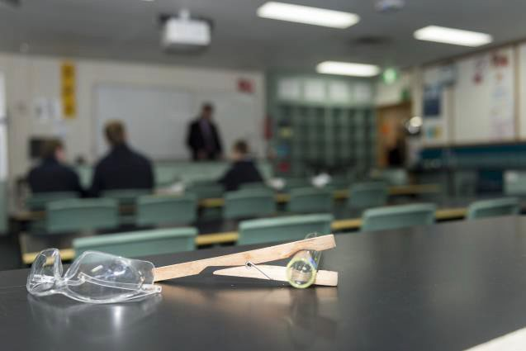Students who have problems coping with the Magellan environment are advised of ways to perform more successfully. If they are still unable to benefit from and contribute to the Magellan Class, they may be placed in other classes where they will be able to achieve more success.

Students in Magellan are expected to maintain a commitment to participation in extracurricular activities and the corporate life of the school.

Further Information

Further information may be obtained from:
- The MCSS website (http:// www.mcss.act.edu.au/),
- Contacting the school on 6142 0333, or
- Contacting the Deputy Principal:
Asish Chandra
p - 6142 0333
e - Asish.Chandra@ed.act.edu.au

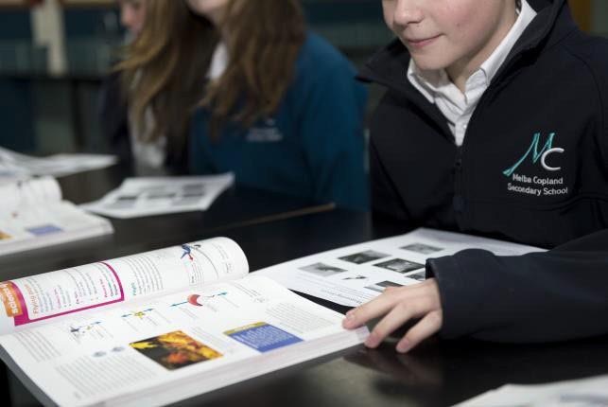

Magellan Program Year 7 - 2023
Application for Enrolment

Student’s Name: Click or tap here to enter text.

Address: Click or tap here to enter text.

Current primary school: Click or tap here to enter text.

Please state briefly why this student should be enrolled in the Magellan Program.

Click or tap here to enter text.

Will one or more parents or guardians be available for an interview during the period?
6th June to 29th July 2022 ☐Yes ☐No
The School will contact parents to arrange a suitable interview time. If you will be unavailable for interview between 6th June to 29th July 2022, please contact the Front Office on 6142 0333 at MCSS to arrange an alternative time.

Name of Parent or Guardian:

Signature: Click or tap here to enter text. (just write name if completing electronically).
Best Contact number: Click or tap here to enter text.
Email Click or tap here to enter text.

Please return this form by Friday 3rd June 2022 directly to: MCSS High School Campus Front Office, email: MCSS.StudentService@ed.act.edu.au

Students applying for entry to the Magellan Program should write briefly about …

Why I should be in a Magellan Class?…
Enjoyment of learning (what do you like to learn about?)
Click or tap here to enter text.

Describe yourself as a learner

Click or tap here to enter text.

Outline your other Community Interests

Click or tap here to enter text.

