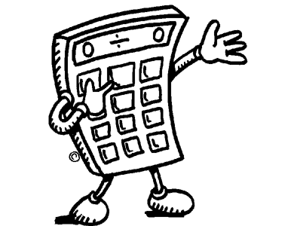
Maths Style Guide

Important things to remember when doing Maths at Melba Copland Secondary School

Ensure you have the correct equipment to bring to each class:
- Exercise book (200 pages minimum)
- Manilla folder/Plastic sheet ( to collect worksheets)
- 2 lead pencils, blue pen, red pen, eraser
- Ruler
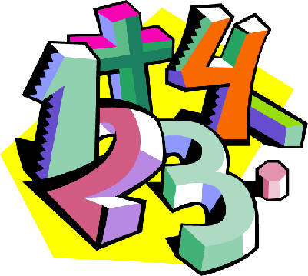
- Scientific calculator
- You textbook (if issued by your teacher)

HOT TIPS for improving your Maths

- Read the whole question
- Think about what the question is asking you
- Work out whether you need to use × ÷
- Set out your clearly
- Work in neat columns
- Date your work so it is easy to refer to when revising
- Use the methods which work best for you to solve problems
- First do a quick mental estimation to check if your answers make sense, THEN check your answers with a calculator if you need to
- Think about whether your answers make sense - take your time
10. Try to learn from your mistakes, rather than being disheartened by them

Completing a Maths Assignment
On the front page of each separate assignment and test paper that you will be issued during the year, will be a list of expectations for that particular task. These will include the outcomes for that particular unit and their weightings.

- Establish what you are being asked to do in each section/question. Look for and underline the key terms, eg: calculate, find, solve, simplify, etc.

- Refer to the rubric or marking criteria to understand how you will be assessed

- When necessary draw diagrams or use the diagrams that you have been given

- Hand in a draft to show your teacher ahead of time

- Include a bibliography when it is needed

Strategies for Problem Solving in Mathematics

The strategy approach to problem solving is based on the following:
- Strategies are process skills which can be learned
- Strategies may be used to solve a variety of problems
- A variety of strategies may be used to solve a single problem
- Strategies may be used singly or in combination to solve a given problem

How do we solve a problem when we have no idea how to go about it?
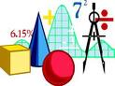
Identify the Facts
- What facts are relevant?
- Are facts missing?
- What are the key words?
- Can the problem be restated more simply?
- Is it possible to estimate?

Plan
- Decide on a strategy.
- What mathematical operation should be used?

Solve
- Carry out the plan using appropriate mathematical skills

Review
- Is the solution found by this strategy reasonable?
- Does it answer the question?
- Is there an alternative or possibly simpler strategy which could be used to solve the problem?

Some problem solving strategies that you can use include
- Guess and check – often the resulting trial
- Look for a pattern
- Act it out
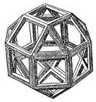
- Make a drawing/graph
- Write a number sentence
- Make a model
- Make a table
- Solve a related problem that is simpler
- Work backwards
- Account for all possibilities

Bear in mind that some strategies are less complex than others, choose the strategy most suitable for the situation.

