 | Melba Copland Secondary School  Consent Form | 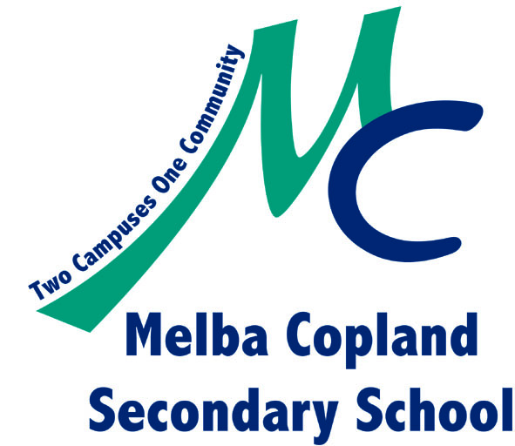

Dear Parents/Guardians.

My name is Marcus Tolley. I am presently completing internship hours at MCSS, to meet the Exercise & Sports Science Australia (ESSA) exercise science practicum.

Relevant qualifications include;
- (3rd yr) UC – Bachelor degree in Exercise Physiology and Rehabilitation.
- Australian Strength and Conditioning Association - Level 1 Coach.
- Australian Weightlifting Federation - Club Weightlifting / Sports Power Coach 1.
- NSW Office of Sport & Recreation - Combat Sports Authority - AM/Pro Trainer & Second.
- Diploma in Fitness.
- Australian Institute of Sport Trainer.
- Multiple years coaching athletes at club, state and national level.

My current role at MCSS has had me working with students enrolled in the Talented Athlete Program (TAP) and group PE sessions so many students may already be familiar with me. I would like to extend the opportunity for the wider school population to participate in small group training sessions tailored to their personal needs.

The focus of these sessions will be on developing safe exercise practice (general safety, posture, technique, use of equipment and understanding of limitations) and development of lifelong transferable physical skills.

Sessions will prioritise quality over quantity.

Session format will comply with ASCA ‘Resistance training for children and youth’ LINK and the Australian Sports Commission ‘Physical literacy framework’ LINK.

Sessions are scheduled for lunchtimes during Term 3 2020 limited to a maximum of 10 participants per squad.

Enrollment to these sessions is voluntary but does require the return of this signed permission note and Pre-exercise screening Questionnaire.

One the sessions have started; I would like students to communicate with me if unable to attend.

If you’d like to communicate with me directly, with any questions, concerns or special requests, please email me: u3190659@uni.canberra.edu.au

----------------------------------------------------------------------------------------------------------------------------------

I give permission for my daughter/son …………………...……………. ……………… to take part in Personal Fitness Training sessions at lunchtimes starting Week 1 Term 3 2020 for 10 weeks.

While the activity is being conducted by a University of Canberra Intern, there will be a MCSS staff member acting in a supervisory role for each session.

- Medical attention may be sought, or emergency arrangements may be made for the student.
(Please note that that ambulance transport is free in the ACT only)
- Inappropriate student behavior will be managed as per normal MCSS rules of safe, respectful behaviour.

*Please complete the attached medical information paperwork highlighting any special requirements the supervisor may need to be aware of.

Specific permission for _________________________________ (students full name)

I have read the attached information regarding this activity and understand what it contains.

Full name of parent/guardian (please print): …………………………………………….

Signature of parent/guardian: ……………………………. Date: …………………

